**Elastic file system:**

**It helps to copy the data from one server to another.**

**[] Go to EFS**

**[] select create file system**

**[] select customize**

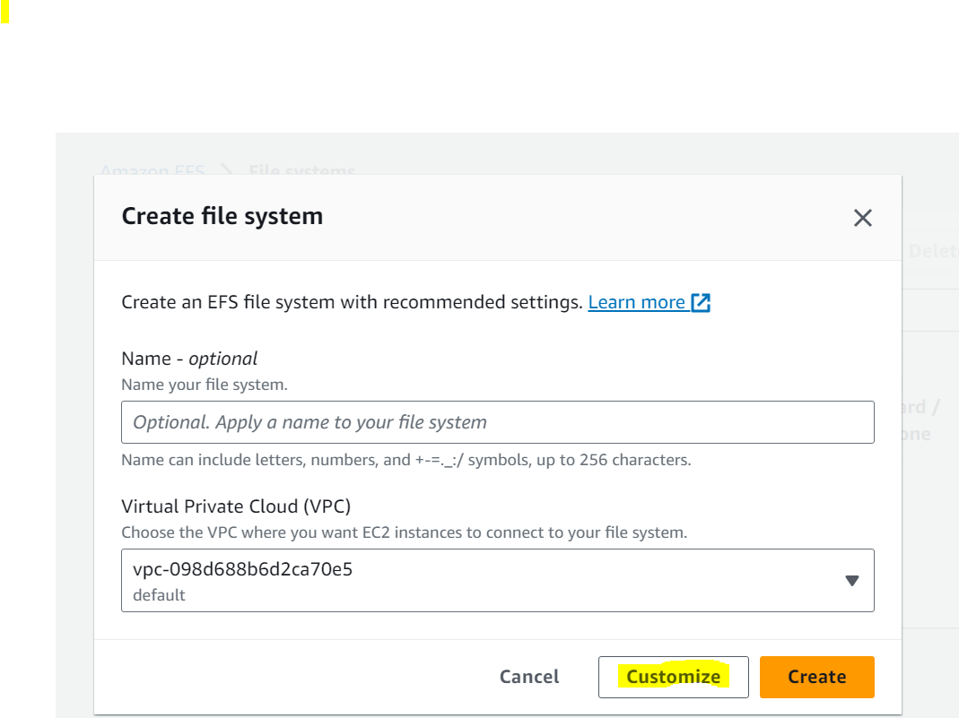

**[] name**

**[] standard**

**[] in lifecycle management, select as our wish**

**[] in throughput mode**

**[] select enhanced**

**[] next**

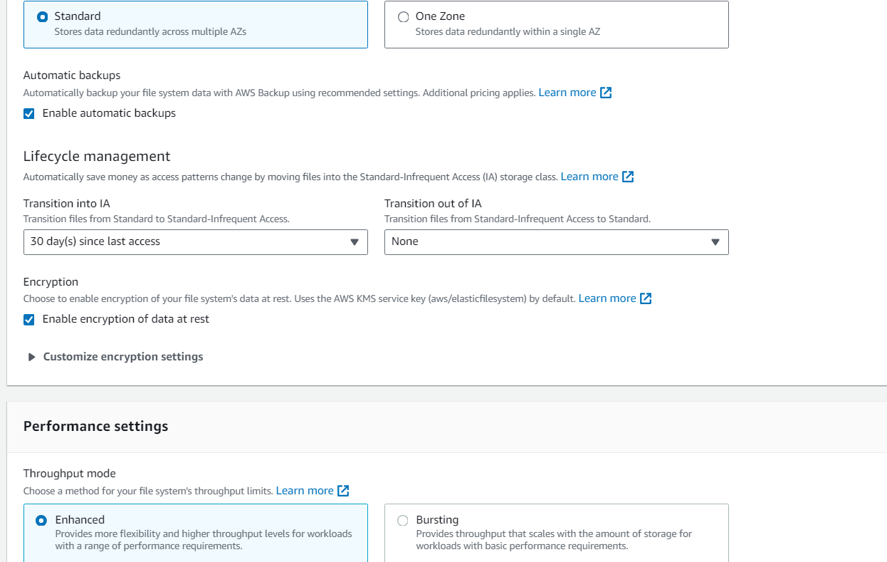

**[] select VPC which we want**

**[] in mount targets select our security groups**

**[] lunch 2 instances, (amazon Linux)**

**[] connect through putty**

**Instance A**

**[] sudo su -**

**[] sudo yum install –y amazon-efs-utils**

**[] mkdir efs**

**[] go to EFS**

**[] select created EFS**

**[] in that select attach**

**[] select mount via DNS**

**[] copy that command (EFS mount helper)**

**then go to server**

**[] paste copied commands**

**EX:(sudo mount -t efs -o tls fs-0984fcf787fbd5993:/ efs)**

**[] cd efs**

**[] vi hello.txt ( enter whatever)**

**In instance B**

**[] sudo su -**

**[] sudo yum install –y amazon-efs-utils**

**[] mkdir efs**

**[] paste copied commands here also**

**[] cd efs**

**[] ls (we get hello.txt file here means it copy the instance A file to instance B)**

